**EXPERIMENT NO:1**

**EXPERIMENT NAME: VOLTAGE AND CURRENT MEASUREMENTS IN DC CIRCUITS**

**OBJECTIVES OF THE EXPERIMENT:**

-To carry out current and voltage measurements in DC circuits by creating the experimental circuit using the necessary elements.

-To learn how to connect the voltmeter used in voltage measurement and the ammeter used in current measurement to the circuit.

-To perform current and voltage measurements using ammeter and voltmeter in different circuit types.

**EXPERIMENT CIRCUIT**

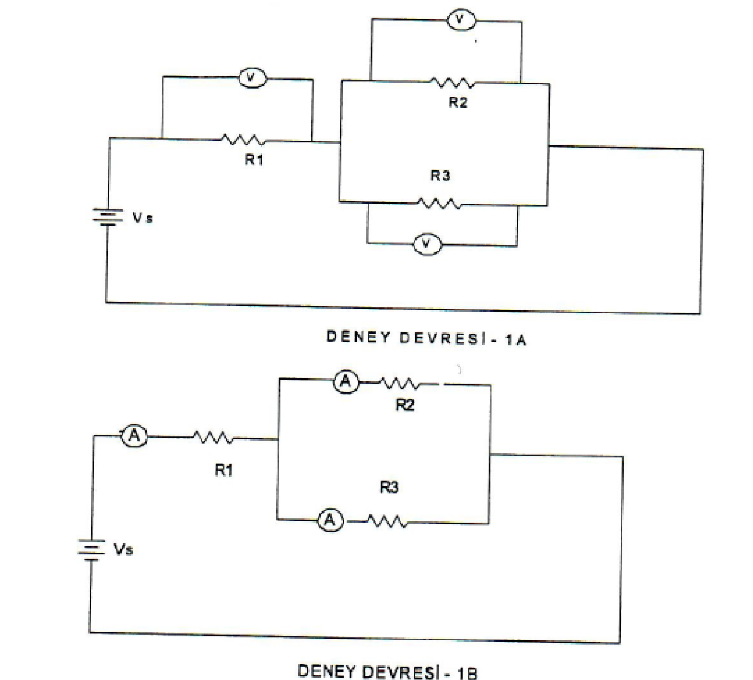

**EXPERIMENT STEPS:**

1. R1=5 kΩ, R2=4 kΩ, R3=12 kΩ

Calculate RT, V1, V2, V3 voltages and I1, I2, I3 branch currents for VS = 12 volts, taking into account the experimental circuit (EXPERIMENT-1A, 1B). Record the values you found in Table-1. Check whether it provides the voltage value VS = VT.

|  |  |  |  |  |
| --- | --- | --- | --- | --- |
| **Resistor values** | **R1** | **R2** | **R3** | **RT** |
| 5 kΩ | 4 kΩ | 12 kΩ | 8 kΩ |
| **Calculated voltage values** | **V1** | **V 2** | **V 3** | **V T** |
| 7.5v | 4.5v | 4.5 v | 12v |
| **Calculated current values** | **I1** | **I2** | **I3** | **IT** |
| 1.5mA | 1.125mA | 0.375mA | 1.5mA |

**Table-1**

1. Set up the experimental circuit in the figure and set VS = 12V.
2. Connect the measuring device as we mentioned in the theoretical part, measure the voltage values ​on each resistor and record them in Table-2.
3. Record the total of these measured voltage values in Table-2. (Check whether the sum of these measured voltage values provides the VS voltage value by comparing it with Table-1.)
4. Connect the measuring device as we mentioned in the theoretical part and measure the I1, I2, I3 branch currents in the circuit and record them in Table-2. (Did you notice the relationship between I2 and I3? Write the necessary explanation in the result section.)
5. Record the sum of these measured current values in Table-2. (Check whether the sum of I2 and I3 currents provides the value of I, current.)
6. Compare the measurement results with all the calculation results you have obtained.
7. Draw the current (I1)-voltage (VS) graph according to the data regarding the voltage and current values you obtained through measurements (according to any fixed resistance value you choose).

|  |  |  |  |  |
| --- | --- | --- | --- | --- |
| **Resistor values** | **R1** | **R2** | **R3** | **RT** |
| 5 kΩ | 4 kΩ | 12 kΩ | 8 kΩ |
| **Measured voltage values** | **V1** | **V 2** | **V 3** | **V T** |
| 7.5v | 4.5v | 4.5v | 12v |
| **Measured current values** | **I1** | **I2** | **I3** | **IT** |
| 1.5mA | 1.125mA | 0.375mA | 1.5mA |

**Table-2 Current-Voltage Graph**

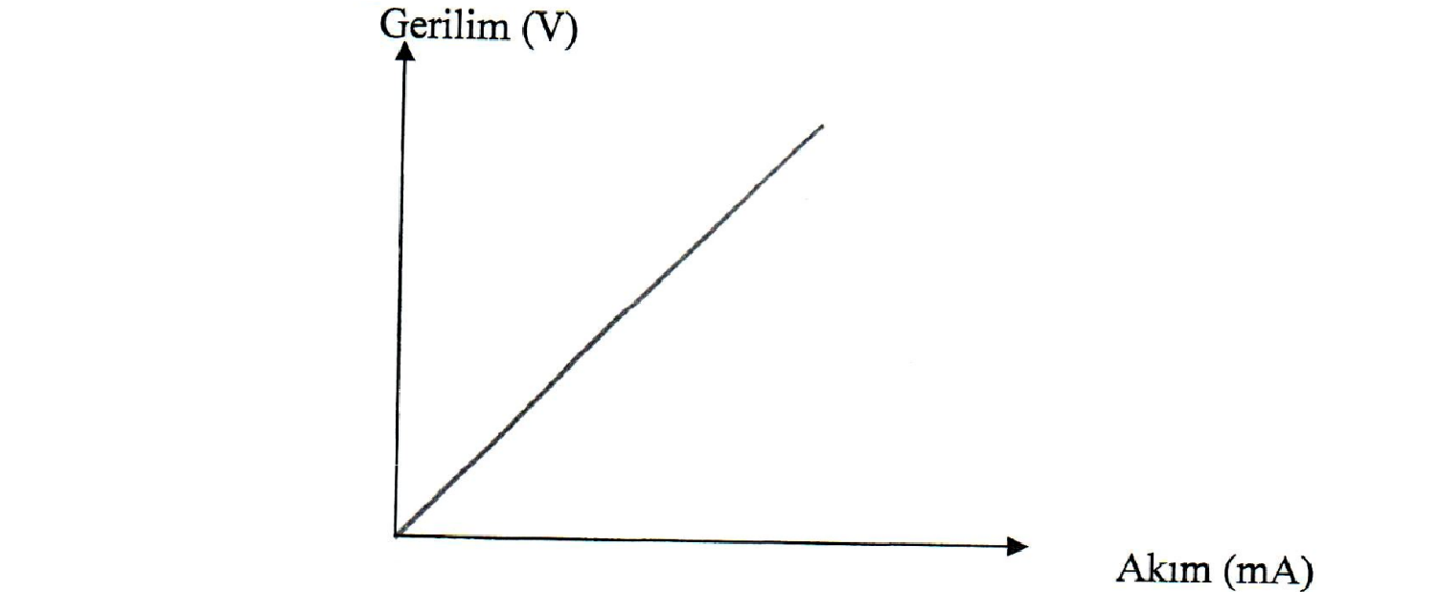

**RESULTS AND DISCUSSION:**

In your experiment, you measured DC voltage and current. You have made the necessary measurements by connecting the measuring instruments to the circuit as mentioned in the theoretical part. Accordingly, while measuring the current in the circuit, the ammeter was connected in series to the circuit. The ammeter has a small internal resistance and is therefore connected in series with the circuit. When measuring voltage, the voltmeter was connected to the circuit in parallel due to its large internal resistance.

Also, let's pay attention to the relationship between I2 and I3 in our circuit and the voltages falling on the branches.

-What is the relationship between I2 and I3? Explain why.

-Explain the relationship between V2, V3 voltages.

-Discuss the relationship between all branch voltages (V2, V3) and V₁.

It is possible to see differences between the voltage and current values we calculated in our experiment and the measured values. These differences are because the resistors used are not at their nominal (label) values due to their tolerances and deviations in the measuring instruments.

**SORULAR:** 1. Current;

1. It is the movement of protons.
2. It is the collision of protons and electrons.
3. It is the movement of electrons.
4. None.
5. Direct current;
   1. Its direction and intensity change over time.
   2. Only its direction changes over time, its intensity does not change.
   3. Only its intensity changes over time, its direction does not change.
   4. Its direction and intensity do not change over time.
6. The potential between the place where the load reaches as a result of applying 1 joule of energy to 1 coulomb of charge and the position of the load before the energy is given; a) 1 joule
   1. 1 watt
   2. 1 volt
   3. 1 ohm
7. If the amount of electricity passing through a certain point in half a minute in an electrical circuit is 75C, what is the current intensity?
   1. 1.0 A b) 1.5 A c) 2.5 A d) 3 A

5 What are the devices that measure current and voltage, respectively?

1. Potentiometer-ammeter
2. Ammeter-ohmmeter
3. Ammeter-voltmeter
4. Voltmeter-potentiometer
5. Provided that the VS voltage remains constant, only R is greater than its nominal value in the test circuit;
   1. V₁ voltage decreases.
   2. V₁ voltage increases.
   3. V2 voltage decreases., V3 voltage increases.
   4. V2 voltage increases.
6. Provided that the VS voltage remains constant, only R2 in the circuit being greater than its nominal value causes I1 main branch current;
   1. Reduces
   2. Increases
   3. Does not affect
   4. None
7. Explain the direction of current.  
     
   The direction of current is the path of electric charge flow in a circuit. Conventional current flow is from the positive to the negative terminal of a voltage source, even though electrons (negatively charged) actually move in the opposite direction.
8. In a circuit, must a voltage be applied to the circuit to ensure current flow?  
     
   Yes, in a circuit, a voltage must be applied to ensure current flow. Voltage provides the electromotive force (EMF) that pushes or drives electric charges (usually electrons) through the circuit. Without a voltage source, there would be no driving force, and electric charges would not flow, resulting in no current.
9. Explain how the voltmeter used to measure voltage is connected to the circuit and why.  
     
   The voltmeter is connected in parallel to measure voltage without affecting the current flow, revealing the potential difference between two points in the circuit.
10. What would happen if the ammeter was connected in parallel to the circuit? Explain.  
      
    Connecting an ammeter in parallel would create a short circuit, disrupting the current flow and potentially causing damage, as ammeters are designed for series connections.
11. In the experimental circuit, how does it affect the branch currents (I2, I3) if one of the resistors in the parallel arms is larger than its nominal value? Does it cause a change in the directions and intensities of these currents?  
      
    If one resistor in a parallel circuit is larger than its nominal value, it increases the overall resistance in that branch. This results in a decrease in the current through that specific branch (Ohm's Law at play). It doesn't change the direction of the currents, but it does alter their intensities, with less current flowing through the branch with the larger resistor.

**Thinkecad Circuit Screenshot**